- How to Install Zabbix Server on Ubuntu 24.04
Environment
OS: Ubuntu 24.04 (Noble)
Zabbix: 7.0 LTS
Please Choose your platform in refer link below.
https://www.zabbix.com/download?zabbix=7.0&os_distribution=ubuntu&os_version=24.04&components=server_frontend_agent&db=mysql&ws=apache

Pre-Installation
- Check NTP and Timezone
$ sudo -s
# timedatectl
# timedatectl list-timezones | grep Bangkok
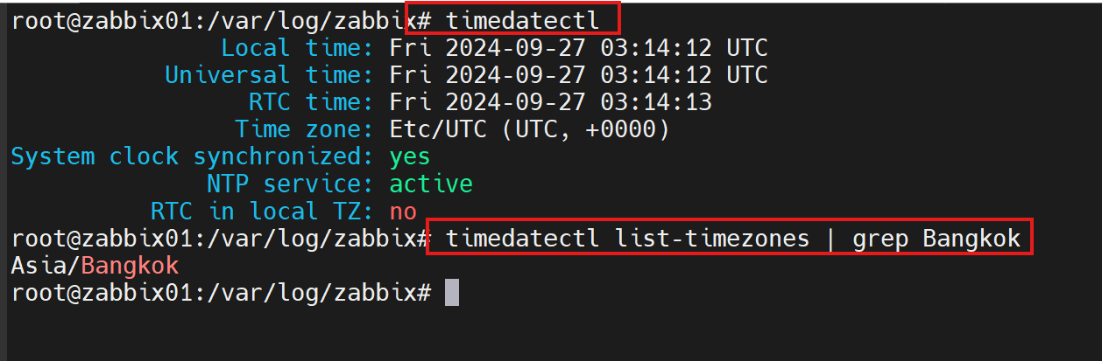
- Set TimeZone
# timedatectl set-timezone Asia/Bangkok

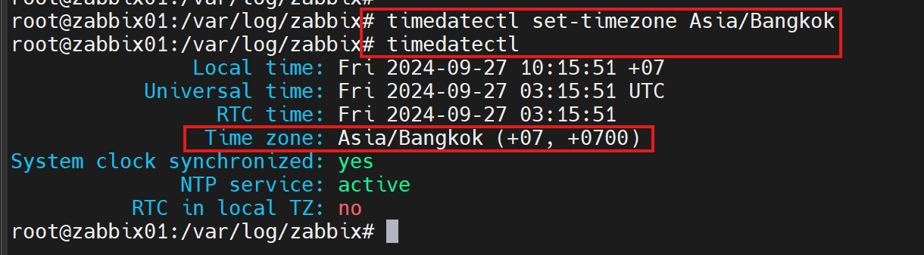

- Update Ubuntu packge
#apt update
#apt install --only-upgrade $(apt list --upgradable 2>/dev/null | grep -i security | awk -F/ '{print
$1}') // upgrade security patch only
#apt upgrade // upgrade all package

- Install NTP Service
#apt install ntp
# vi /etc/ntpsec/ntp.conf
server time1.nimt.or.th
server time2.nimt.or.th
# systemctl restart ntp
# ntpq -p

Remark Default and add NTP Server 10.88.2.1
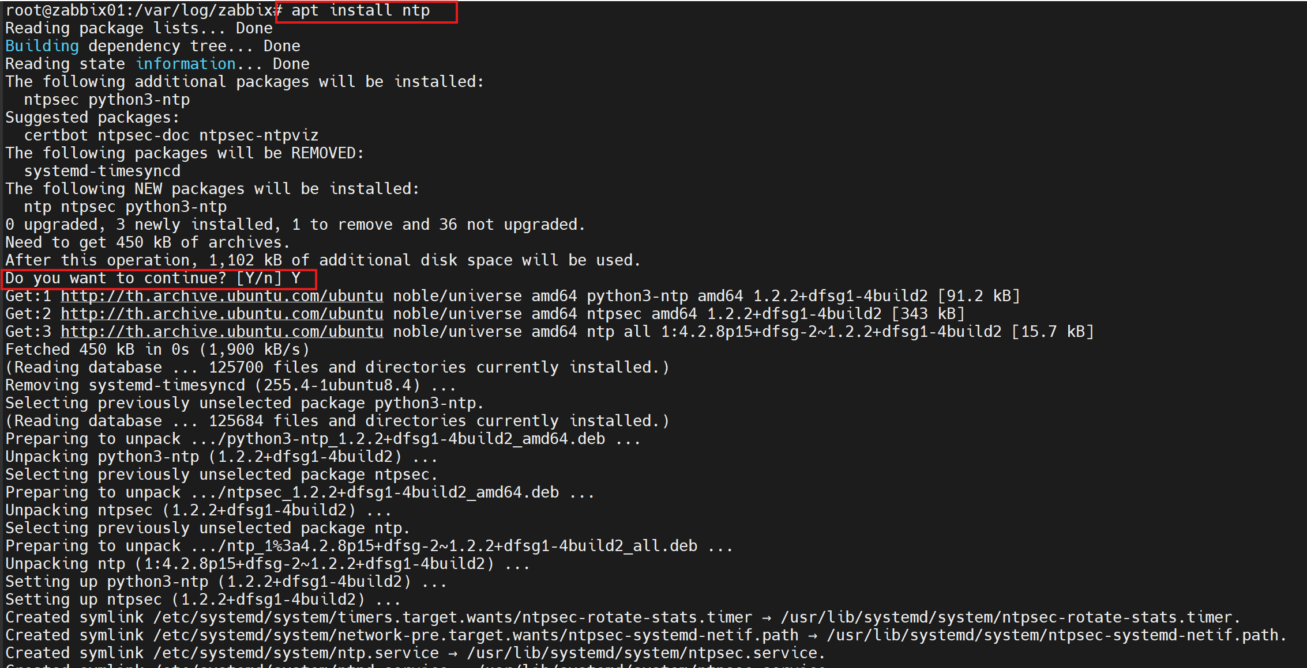
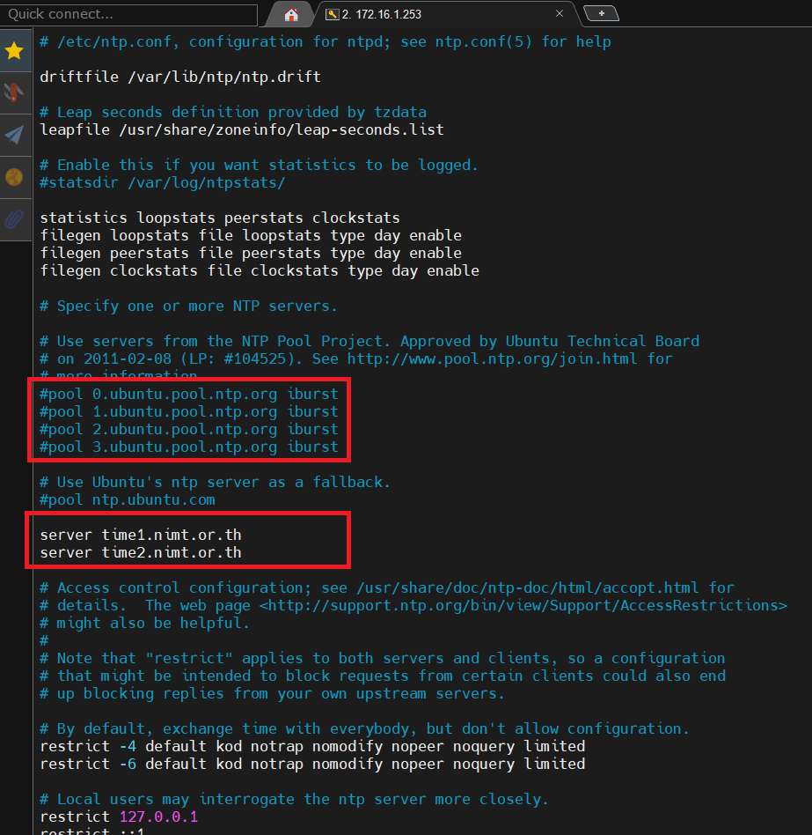
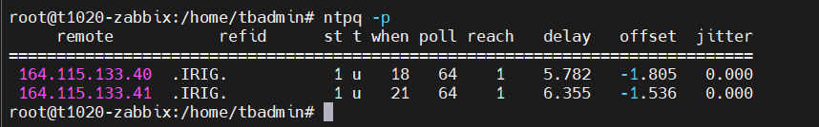
# vi /etc/ntpsec/ntp.conf
แก้ไขไฟล์ตามภาพและใส่ server ดังนี้
server time1.nimt.or.th
server time2.nimt.or.th

Zabbix Installation
a. Become root user
$ sudo -s

b. Install Zabbix repository
please recheck the new version https://www.zabbix.com/download?zabbix=7.4&os_distribution=ubuntu&os_version=24.04&components=server_frontend_agent&db=mysql&ws=apache

# wget https://repo.zabbix.com/zabbix/7.4/release/ubuntu/pool/main/z/zabbix-release/zabbix-release_latest_7.4+ubuntu24.04_all.deb
# dpkg -i zabbix-release_latest_7.4+ubuntu24.04_all.deb
# apt update

Output
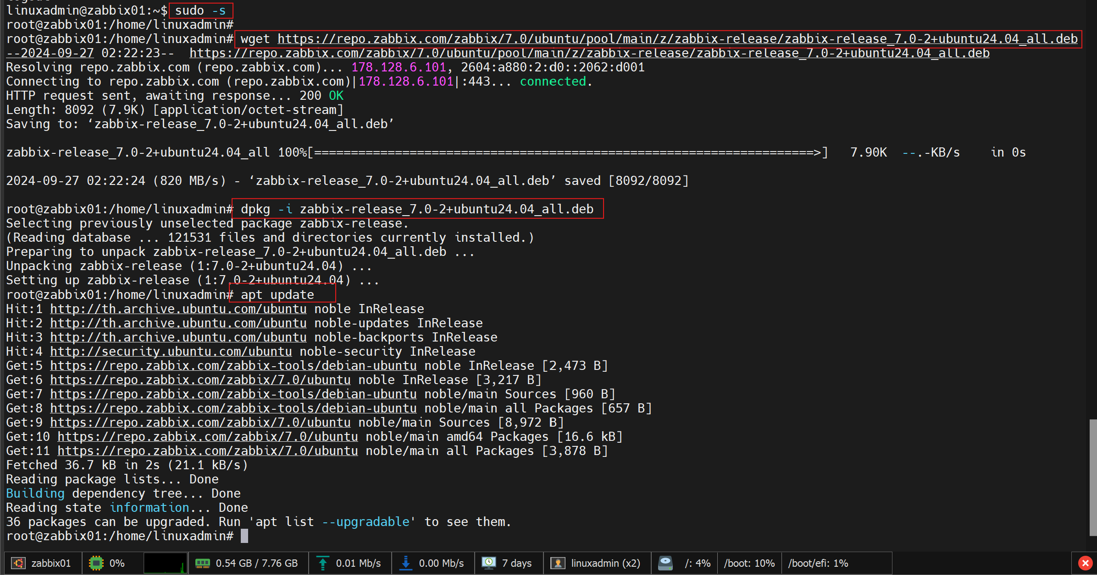

B1. Noted https://ogdenslake.ca/2021/03/03/zabbix-missing-mysql/
vi /etc/dpkg/dpkg.cfg.d/excludes

…and adding the following line about Zabbix:

#... except zabbix
path-include=/usr/share/doc/zabbix*

c. Install Zabbix server, frontend, agent
# apt install zabbix-server-mysql zabbix-frontend-php zabbix-apache-conf zabbix-sql-scripts zabbix-agent

Output
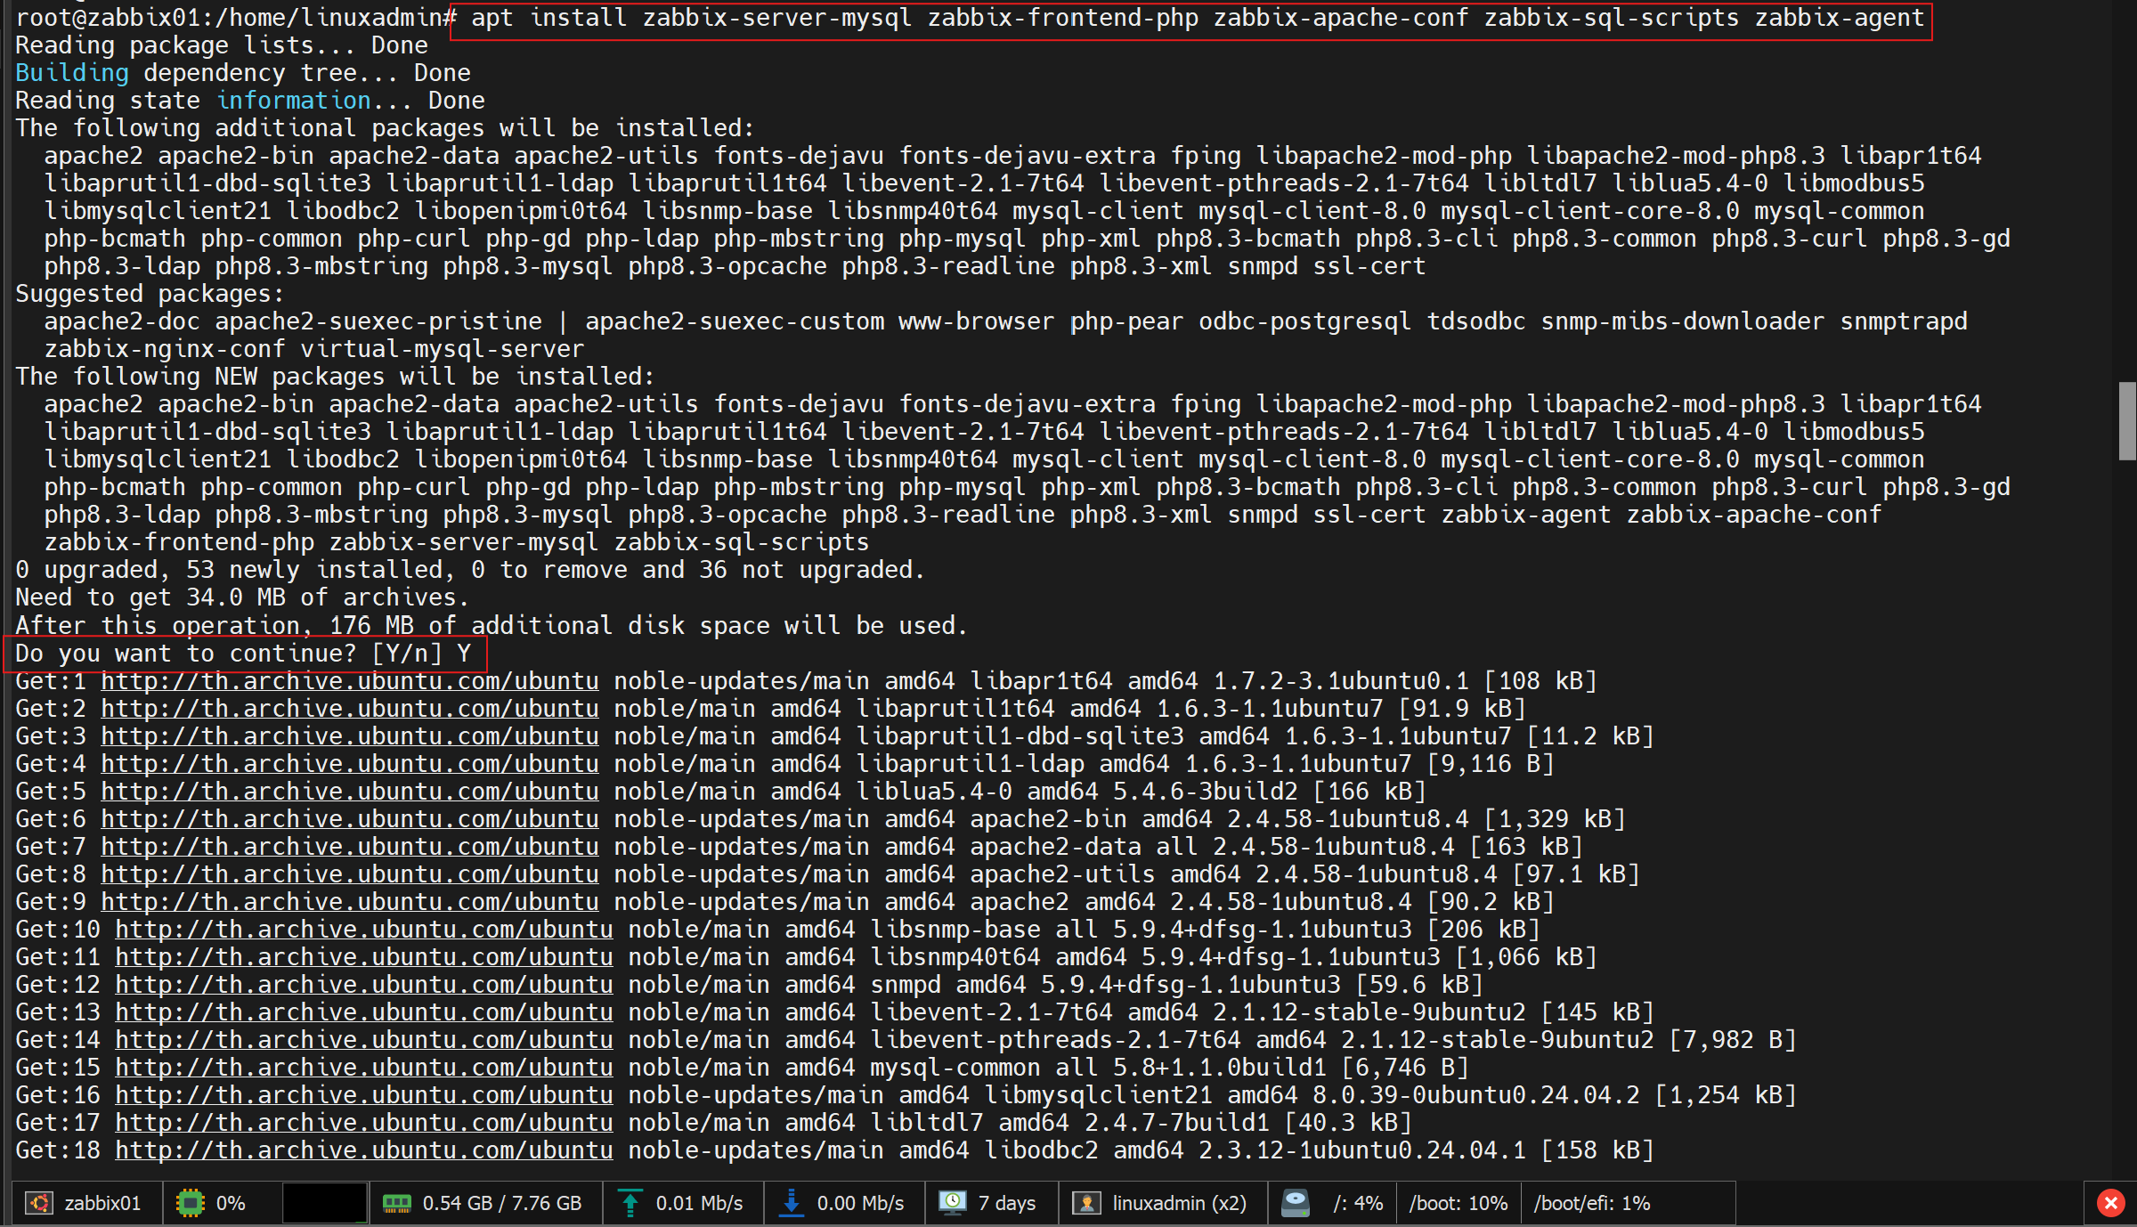

c.1 Install Database mysql.
# apt install mysql-server -y
# mysql --version

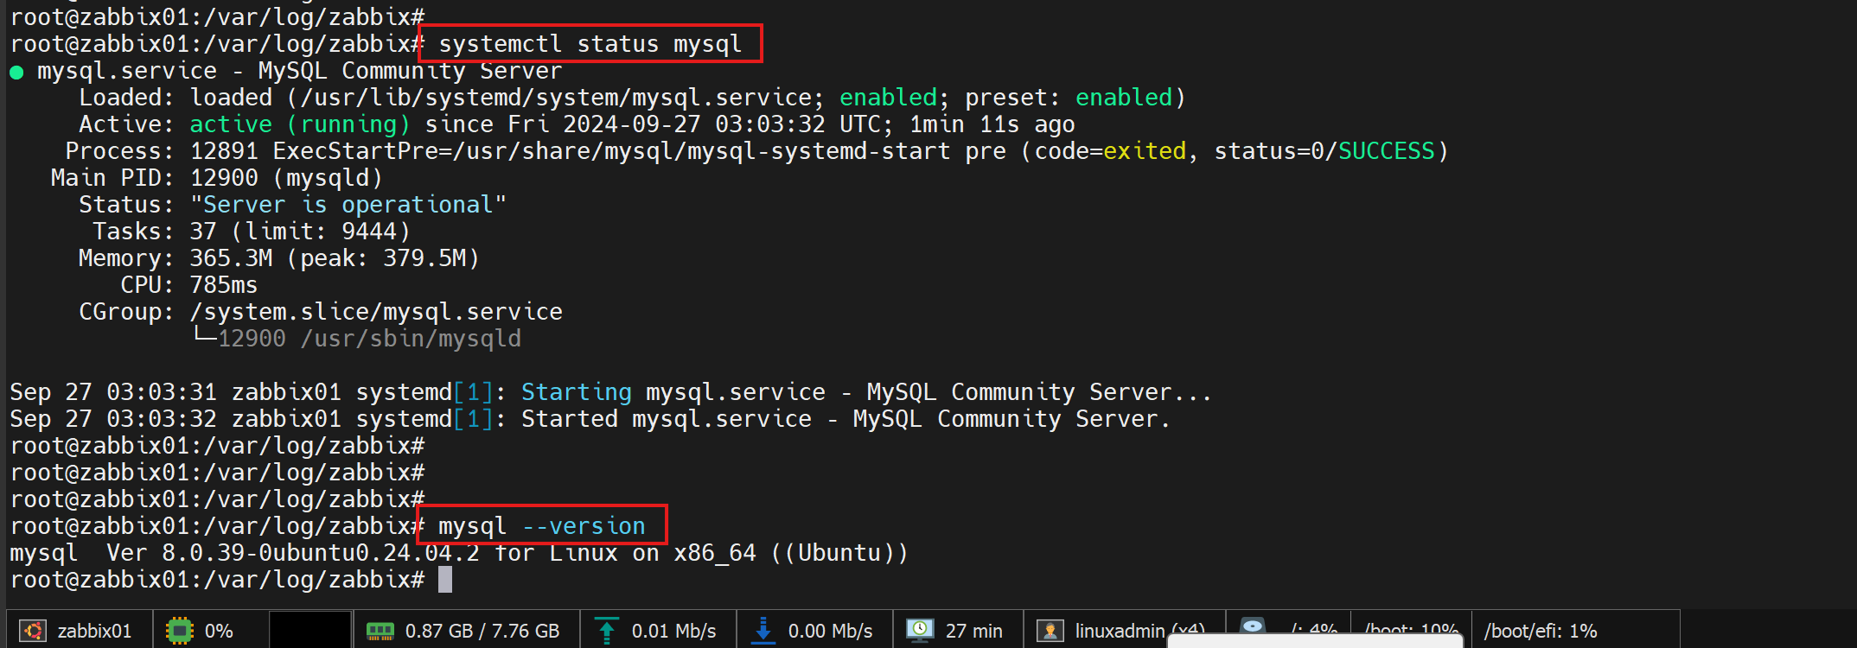
d. Create initial database
Make sure you have database server up and running.
systemctl status mysql

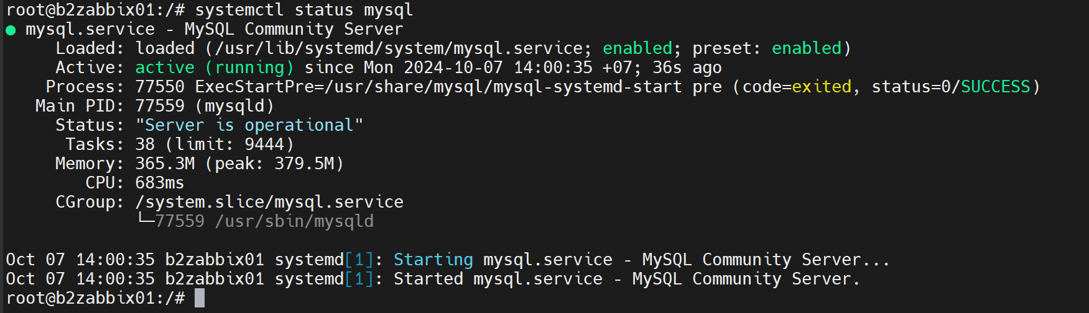
d.1 Run the following on your database host.
# mysql -uroot -p
Password => p6Tm#Z
mysql> create database zabbix character set utf8mb4 collate utf8mb4_bin;
mysql> create user zabbix@localhost identified by 'p6Tm#Z ';
mysql> grant all privileges on zabbix.* to zabbix@localhost;
mysql> set global log_bin_trust_function_creators = 1;
mysql> quit;

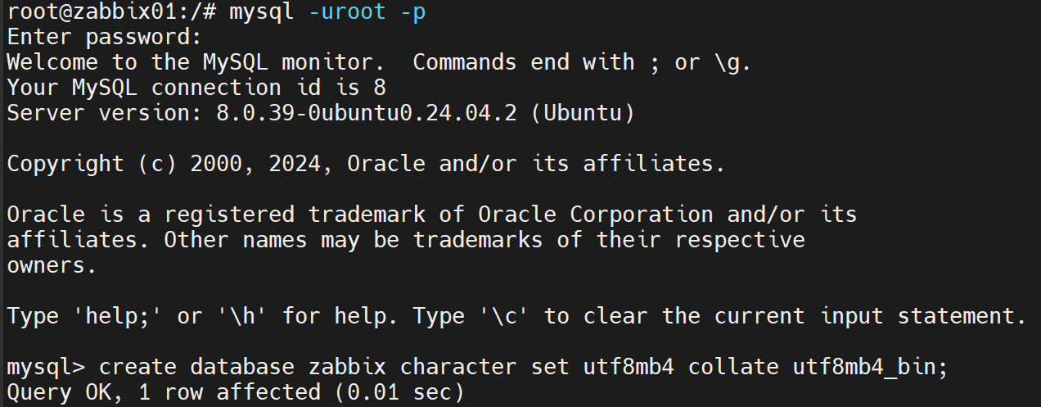
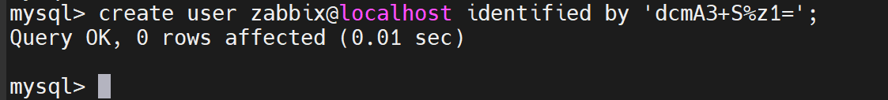
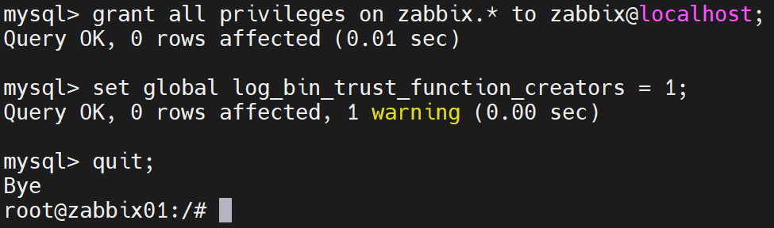

d.2 On Zabbix server host import initial schema and data. You will be prompted to enter your newly created password.
Enter password for mysql user zabbix@localhost
# zcat /usr/share/zabbix/sql-scripts/mysql/server.sql.gz | mysql --default-character-set=utf8mb4 -uzabbix -p zabbix

d.3 Disable log_bin_trust_function_creators option after importing database schema.
# mysql -uroot -p
password
mysql> set global log_bin_trust_function_creators = 0;
mysql> quit;

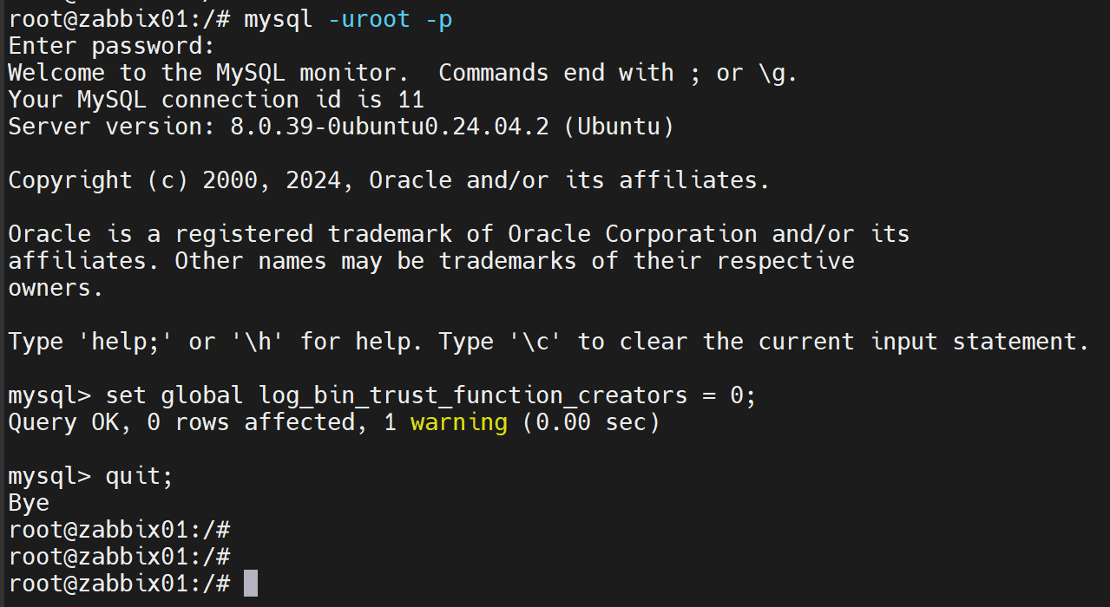
e. Configure the database for Zabbix server
Edit file /etc/zabbix/zabbix_server.conf
#vi /etc/zabbix/zabbix_server.conf

Find this word and insert the password -> DBPassword=password

f. Start Zabbix server and agent processes
Start Zabbix server and agent processes and make it start at system boot.
# systemctl restart zabbix-server zabbix-agent apache2
# systemctl enable zabbix-server zabbix-agent apache2
# systemctl status zabbix-server zabbix-agent apache2

- Initial Zabbix Server

http://10.88.2.22/zabbix/
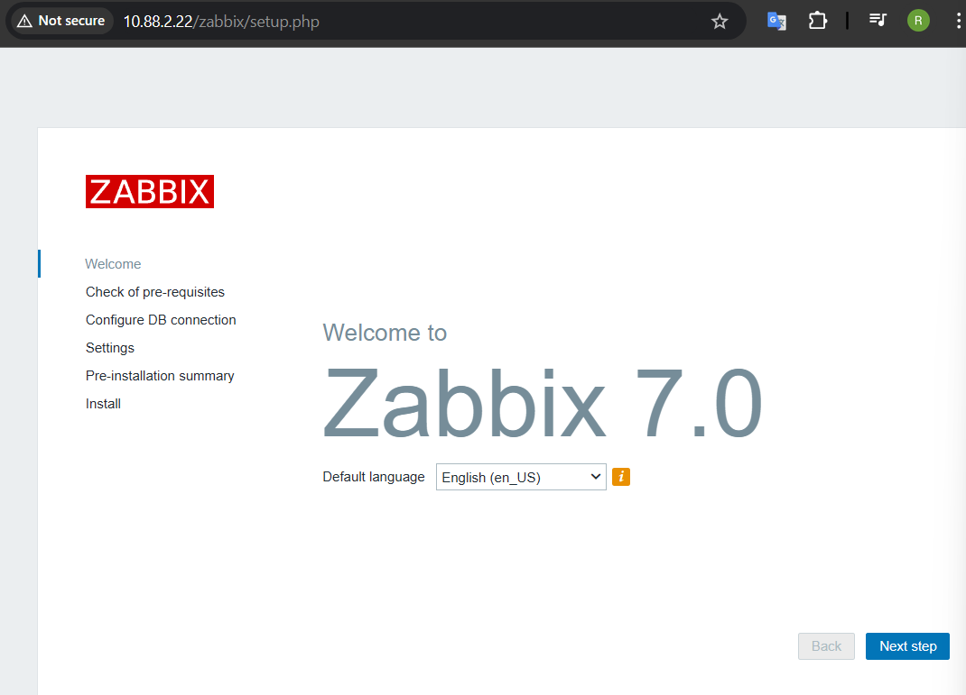

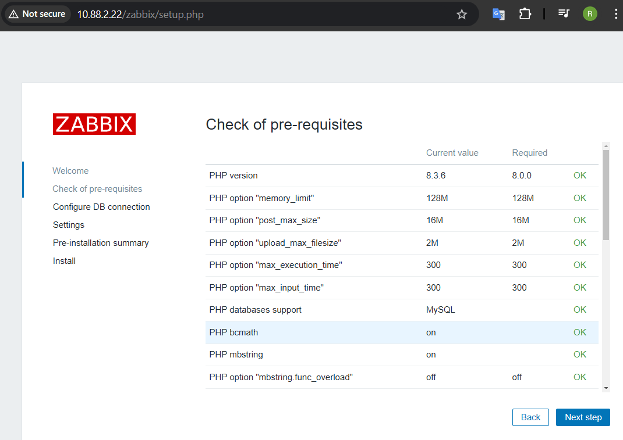
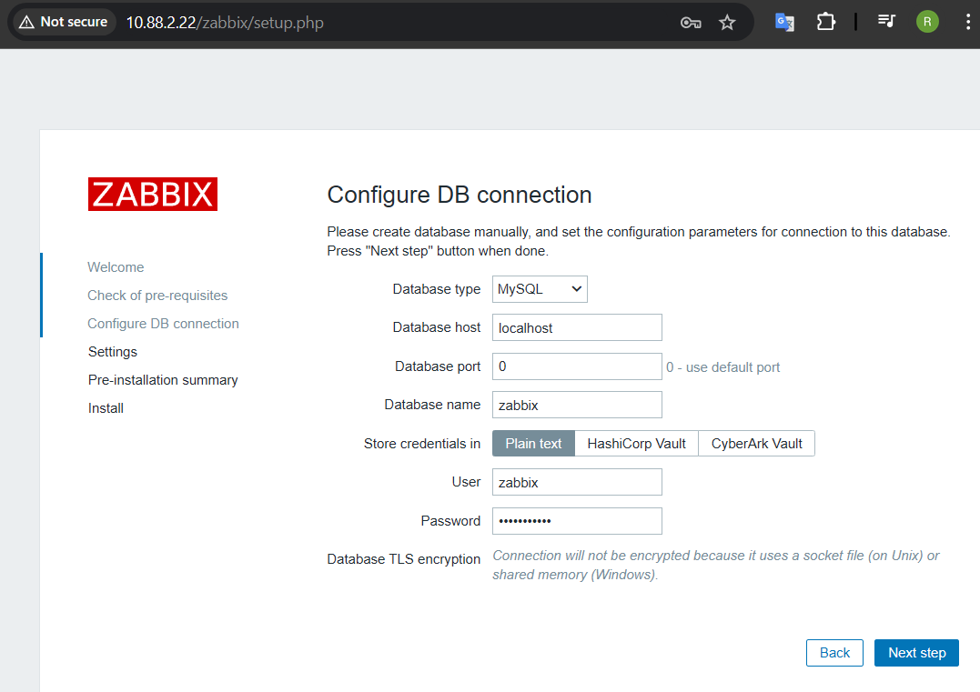
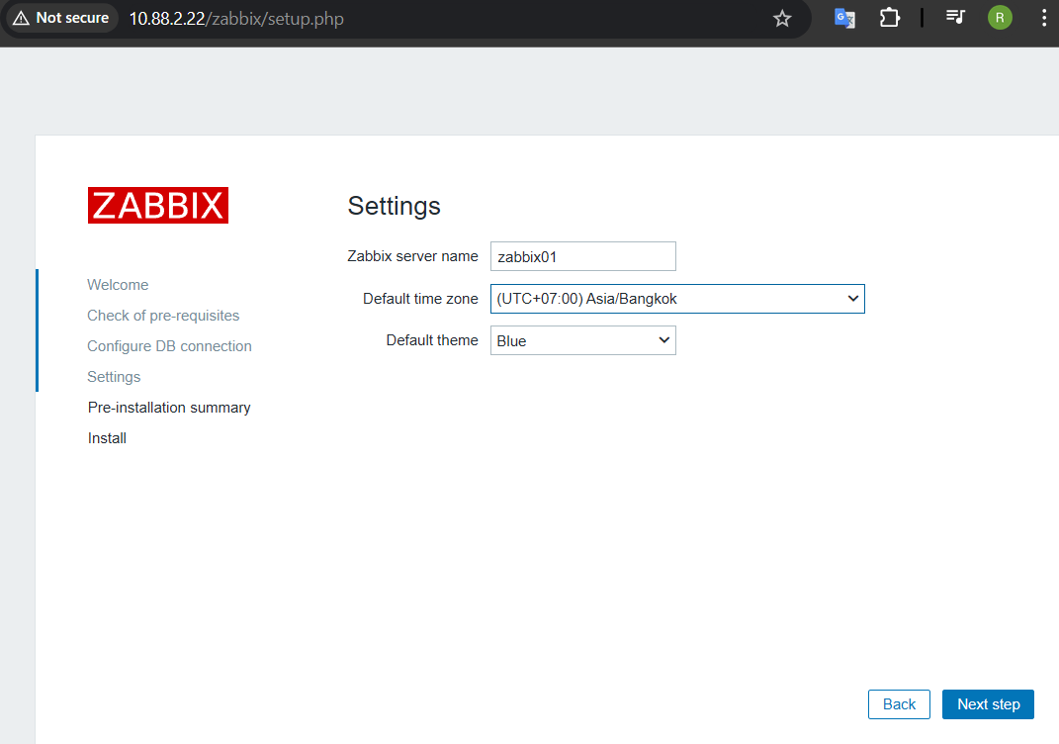
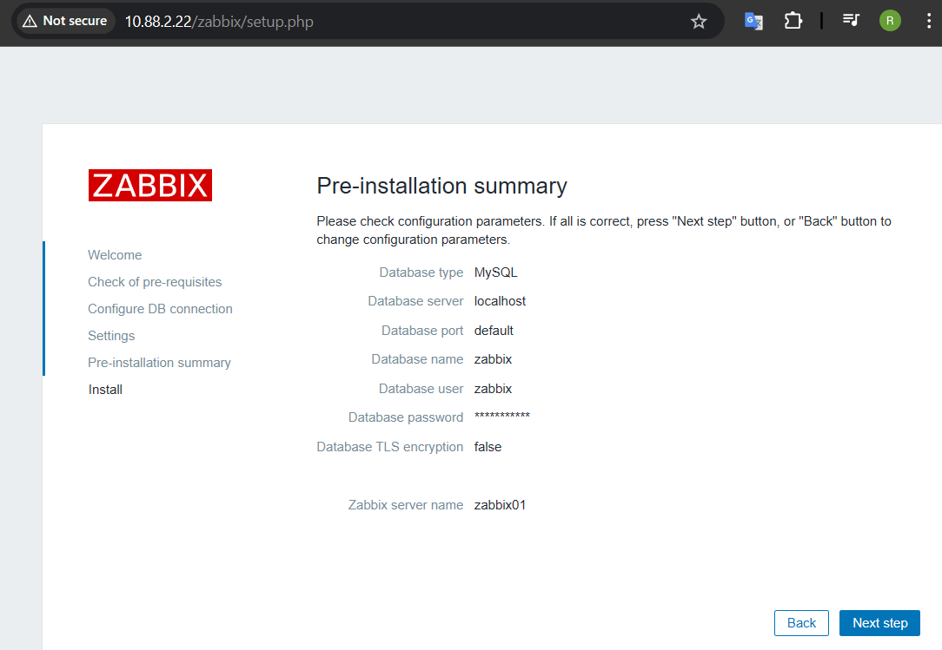
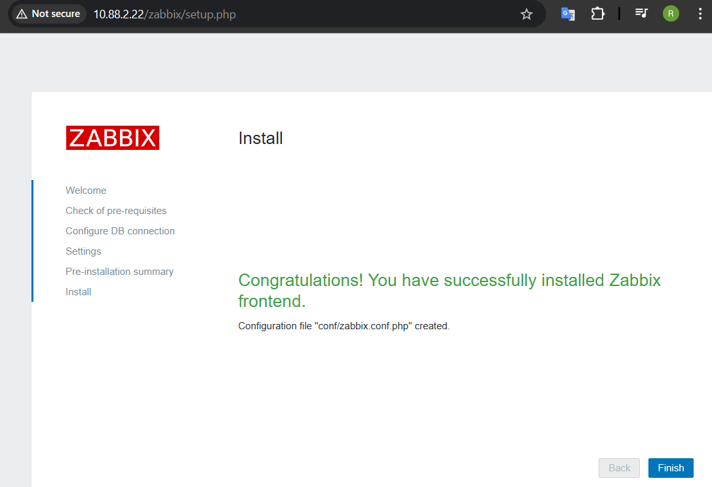

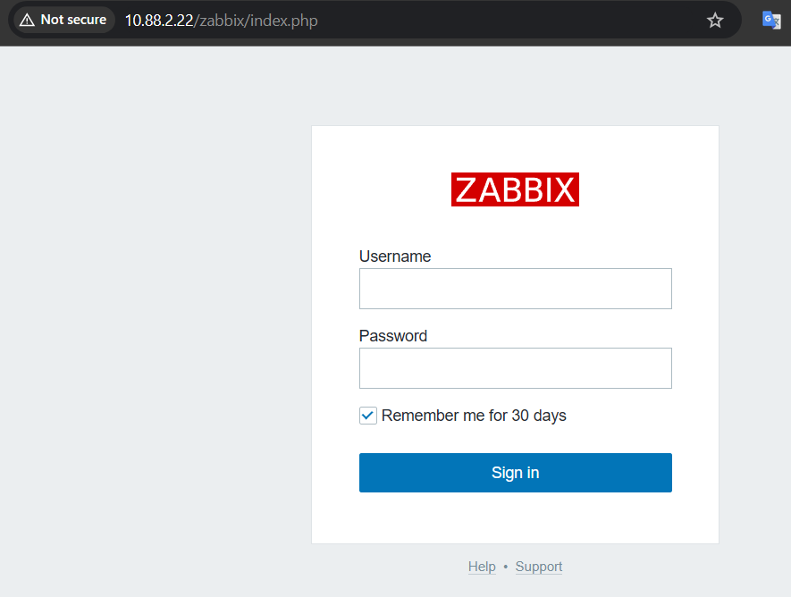
Default: Admin/zabbix

Setting up SSL for Zabbix frontend to use HTTPS
Create a directory for SSL keys:
#mkdir -p /etc/httpd/ssl/private
#chmod 700 /etc/httpd/ssl/private

Enable mod_ssl
# a2enmod ssl
# a2ensite default-ssl
# cd /etc/httpd/ssl/private

Copy Certificate and private key to directory
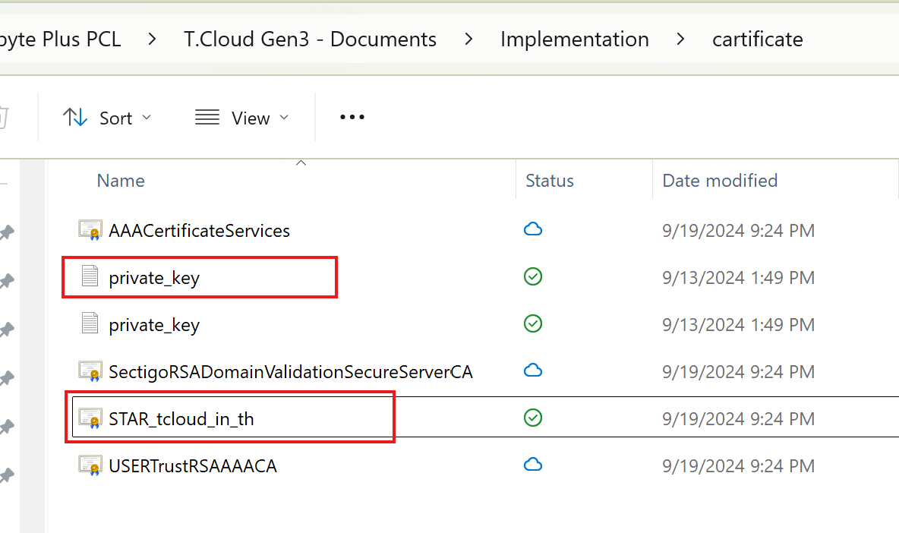
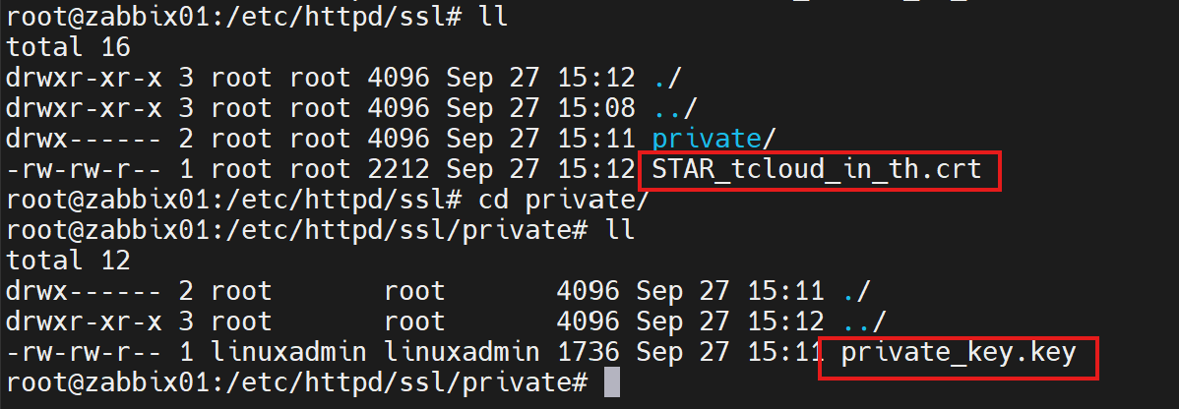

# cd /etc/apache2/sites-available
# vi default-ssl.conf

DocumentRoot "/usr/share/zabbix"
ServerName b2zabbix01.tcloud.in.th

.
.
.
SSLCertificateFile /etc/httpd/ssl/STAR_tcloud_in_th.crt
SSLCertificateKeyFile /etc/httpd/ssl/private/private_key.key

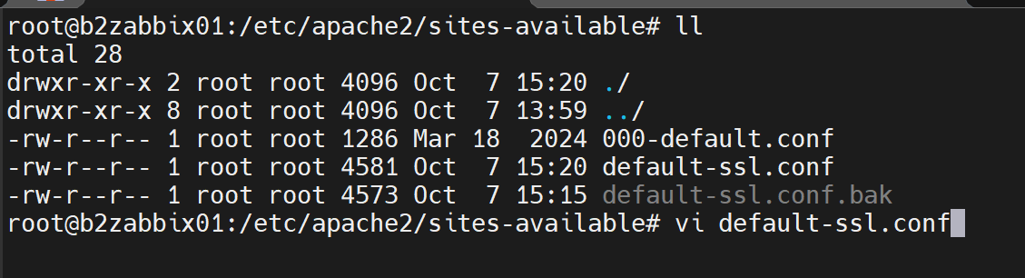

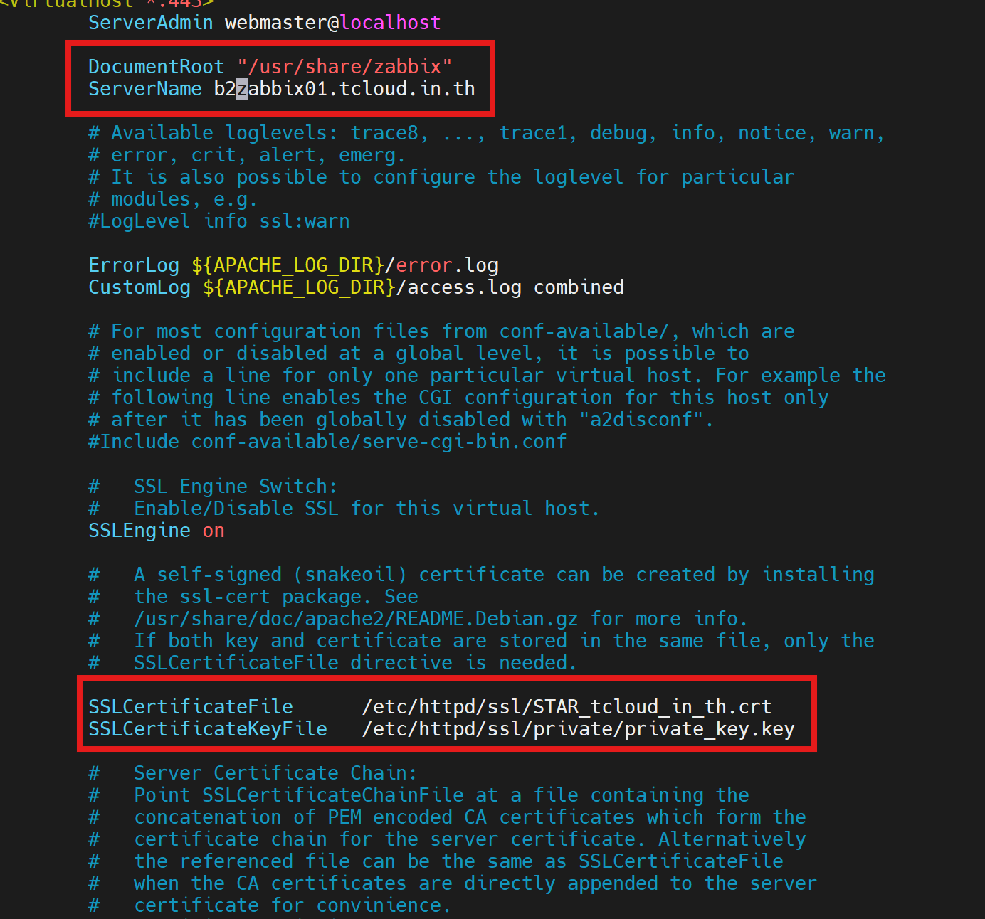
# systemctl restart apache2

Redirect HTTP to HTTPS

vi /etc/apache2/sites-available/000-default.conf

<VirtualHost *:80>
DocumentRoot "/usr/share/zabbix"
ServerName your.domain.com
Redirect permanent / https://your.domain.com/
</VirtualHost>
Restart Service Zabbix
systemctl restart zabbix-server

